

OBJECT PASSING

BY:

ABDULLAH(FA22-BCT-004)

SUBMITTED TO:

MA’AM SANEEHA AMIR.



September 26, 2023

COMSATS UniVERSITY

ISLAMABAD

# **QUESTION#1:**

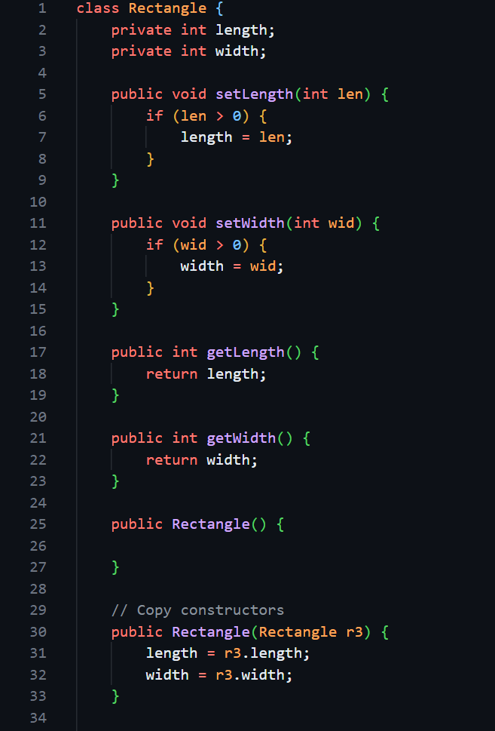

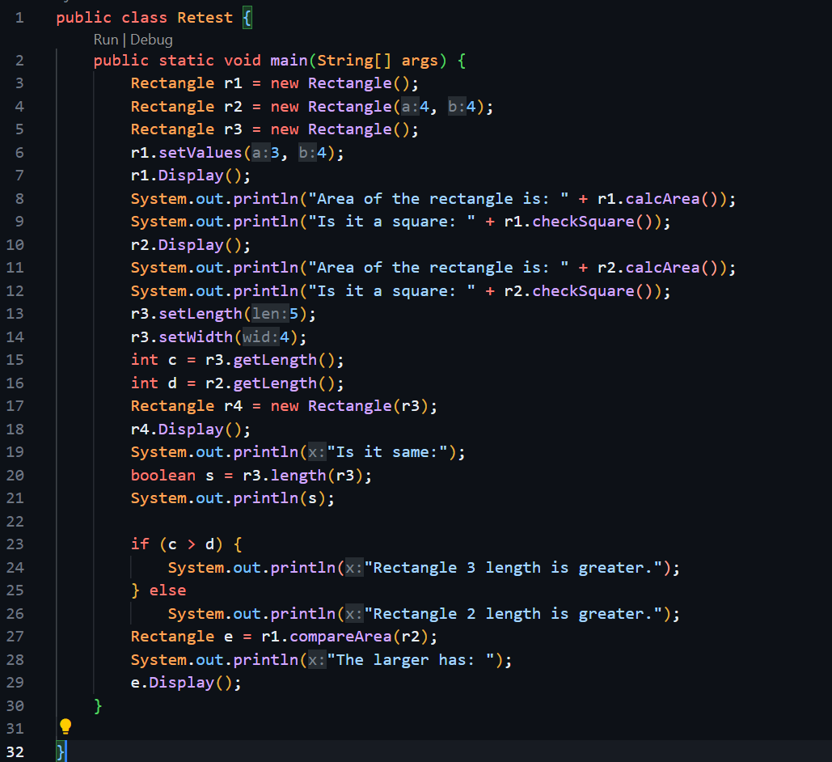

# **QUESTION#2:**

# **QUESTION#3:**

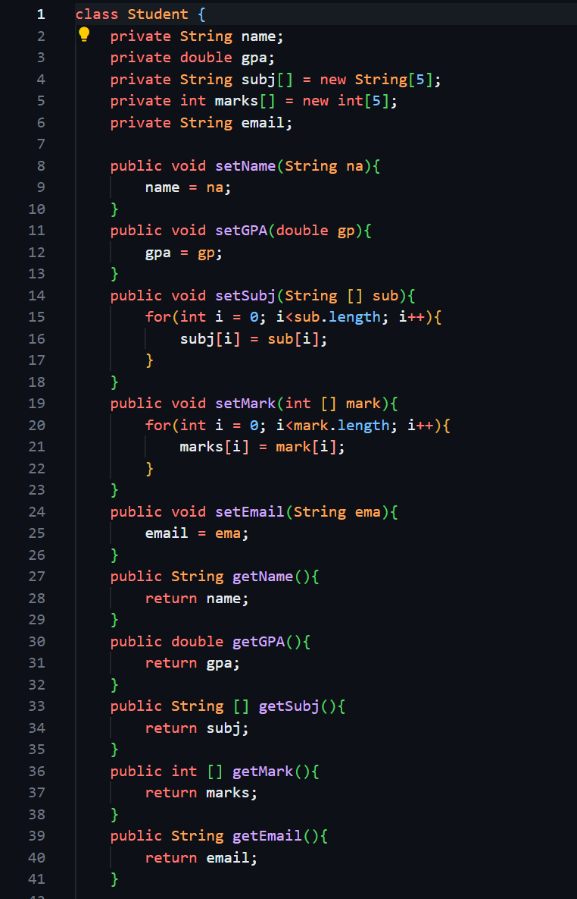

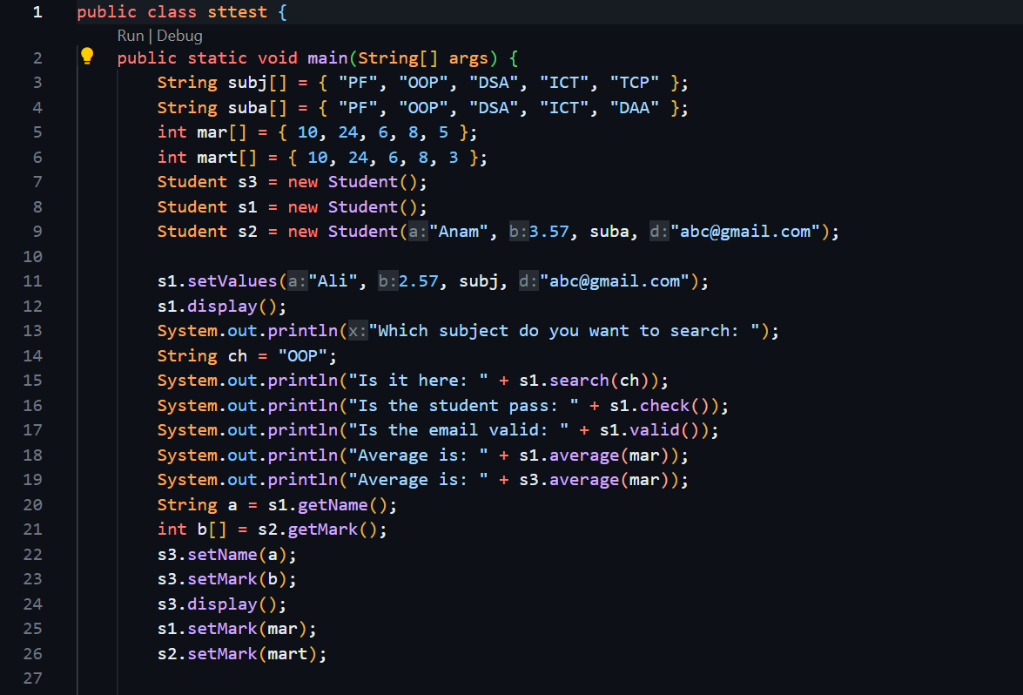

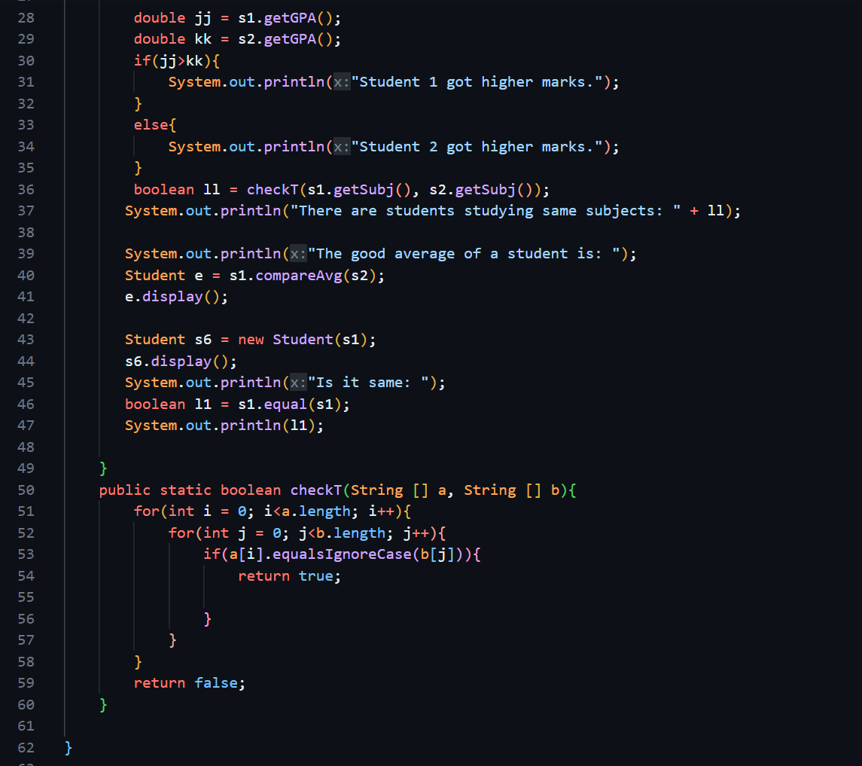

# **QUESTION#4:**

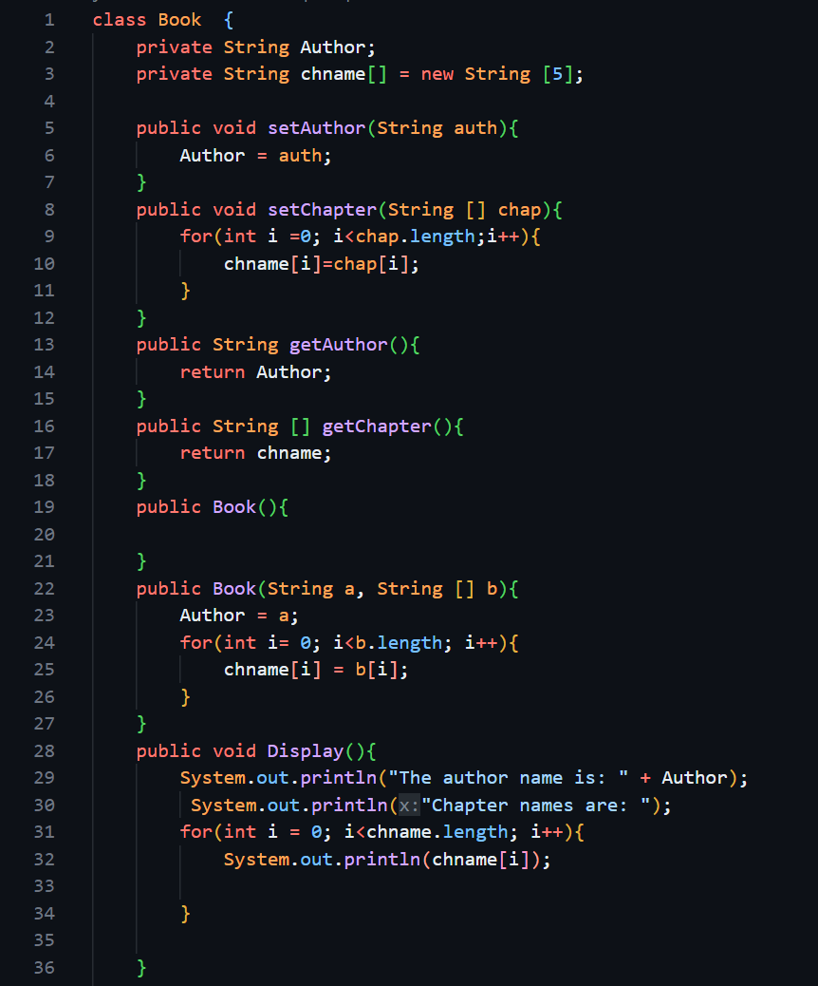

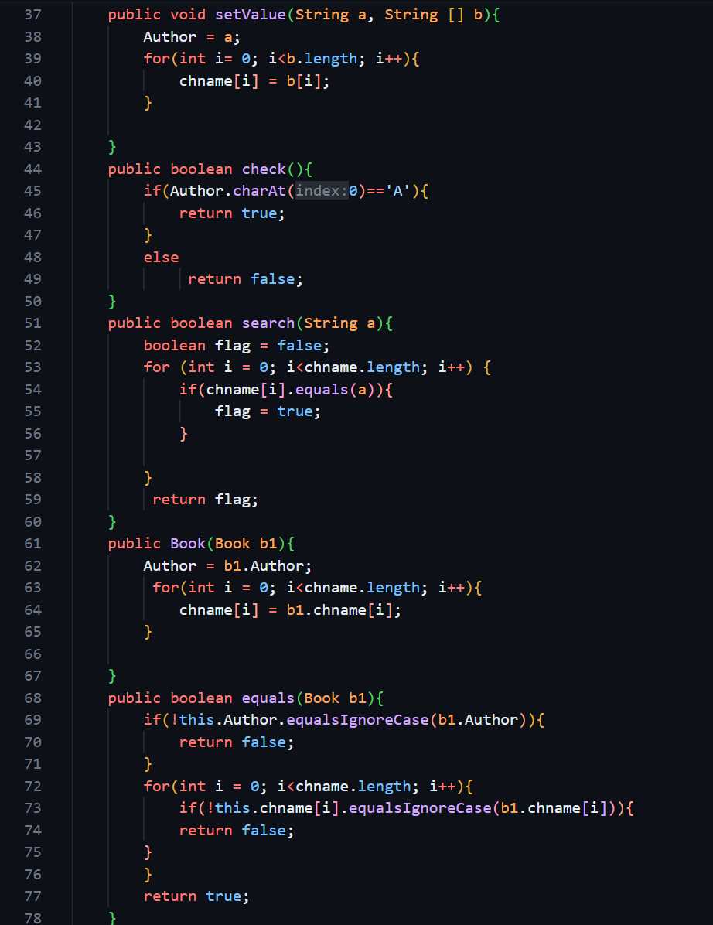

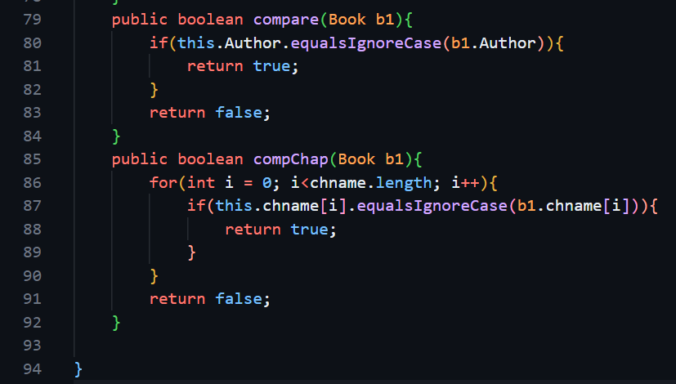

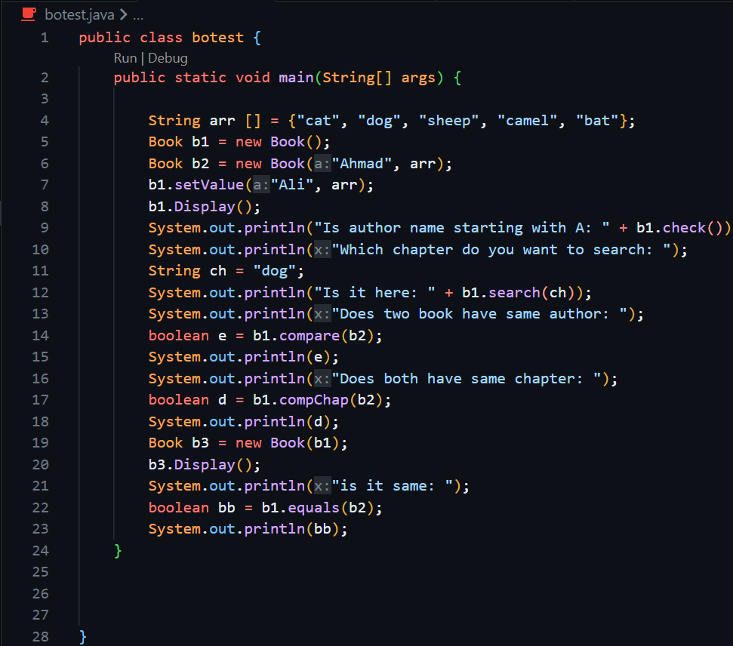

# **QUESTION#5:**

